, why not make it yourself? Implement this:

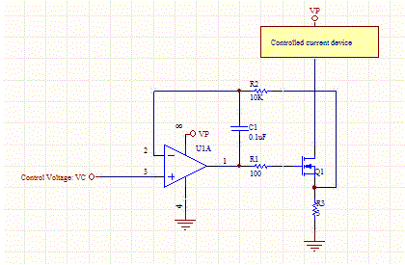

Connect PWM with LPF or DAC to voltage input, and You're good to go. To make it robust You can connect feedback to ADC and implement PID driver, so output will be exactly what You desire. It is easy as a pie, first simulate it with LTspice to check ranges and stuff. You don't need to use expensive IC as well, you can go for low frequency high voltage OPAMPS and single 2n7002 fet driven directly from OPAMP.

**edit2:** WOA? Why do you need such a great mosfet? Is it rated for 80A not mA. Go for small ones, they have way smaller gate capacitance.

[share](https://electronics.stackexchange.com/a/164091)  [improve this answer](https://electronics.stackexchange.com/posts/164091/edit)  follow

[edited Apr 10 '15 at 19:22](https://electronics.stackexchange.com/posts/164091/revisions)

[[https://www.gravatar.com/avatar/c5c03aa1d93f811406bcca1305af1459?s=32&d=identicon&r=PG](https://electronics.stackexchange.com/users/7036/nick-alexeev)](https://electronics.stackexchange.com/users/7036/nick-alexeev)

[Nick Alexeev](https://electronics.stackexchange.com/users/7036/nick-alexeev)**♦**

**34.3k**1111 gold badges7474 silver badges193193 bronze badges

answered Apr 10 '15 at 11:32

[[https://www.gravatar.com/avatar/a05122442aa5d86518ecc6a7dc044cd6?s=32&d=identicon&r=PG](https://electronics.stackexchange.com/users/41438/axel)](https://electronics.stackexchange.com/users/41438/axel)

[Axel](https://electronics.stackexchange.com/users/41438/axel)

**121**55 bronze badges

[add a comment](https://electronics.stackexchange.com/questions/164089/driving-proportional-valves-from-microcontroller)

-1

it depends on how you wish to drive the valve. as mentioned by others, pwm is the most efficient approach. But your particular valve will determine the best way to drive.

the output current follows this approach:

(1 + 3R/1R) * I * 1R = Vdac_out.

so you can work out the math for 165ma drive.